**DSA ASSIGNMENT-2**

**TANISHA KARMAKAR**

**21051950**

**CSE 37**

**Q1. WAP to find the largest number and counts the occurrence of the largest number in a dynamic array of n integers using a single loop.**

#include <stdio.h>

#include <stdlib.h>

int main()

{

int n, biggest, count=1;

int *arr;

printf("Enter the number of elements: ");

scanf("%d", &n);

arr=(int*) malloc (sizeof(int)*n);

biggest=0;

printf("enter the elements of the array: \n");

for(int i=0; i<n; i++)

{

scanf("%d", &arr[i]);

if (arr[i]>biggest)

biggest=arr[i];

else if(arr[i]==biggest)

count++ ;

}

printf("The largest element=%d\n",biggest);

printf("Largest number count=%d times",count);

return 0;

}

**Output:**

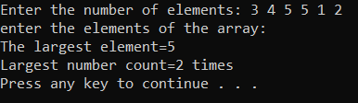

**Q2. Given a dynamic array, WAP to print the next greater element (NGE) for every element. The next greater element for an element x is the first greater element on the right side of x in array. Elements for which no greater element exist, consider next greater element as -1. E.g. For the input array [2, 5, 3, 9, 7], the next greater elements for each elements are as follows.**

|  |  |
| --- | --- |
| **Element** | **NGE** |
| **2** | **5** |
| **5** | **9** |
| **3** | **9** |
| **9** | **-1** |
| **7** | **-1** |

#include <stdio.h>

#include <stdlib.h>

int main()

{

int n;

float *a;

int i, j, found;

printf("\nInput Number of elements : ");

scanf("%d", &n);

printf("\n");

a = malloc(n * sizeof(a));

if (a == NULL)

{

printf("\nMemory not allocated.\n\n");

exit(0);

}

else

{

for (i = 0; i < n; i++)

{

printf("Input the elements %d of Array : ", i + 1);

scanf("%f", &a[i]);

}

printf("Element NGE\n");

for (i = 0; i < n; i++)

{

found = 0;

for (j = i + 1; j < n; j++)

{

if (a[i] < a[j])

{

printf(" %g %g\n", a[i], a[j]);

found = 1;

break;

}

}

if (found == 0)

{

printf(" %g -1\n", a[i]);

}

}

}

return 0;

}

**Output:**

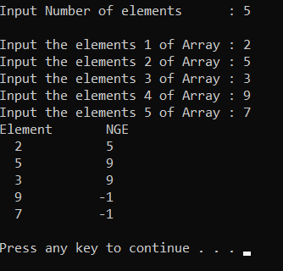

**Q3. WAP to store n student’s information (i.e. student’s roll no, name, gender, marks etc) of an educational institute and display all the data, using array of structure.**

#include <stdio.h>

#include <string.h>

struct Student{

char name[20];

int roll;

float cgpa;

};

int main()

{

int i;

int n=0;

printf("Enter Number of Students: ");

scanf("%d",&n);

struct Student s[n];

for(i=0;i<n;i++){

printf("\nEnter Name:");

scanf("%s",&s[i].name);

printf("\nEnter roll:");

scanf("%d",&s[i].roll);

printf("\nEnter cgpa:");

scanf("%f",&s[i].cgpa);

}

for(int i = 1; i <= n; i++)

{

printf("Name of student %d is: %s\n",i,s[i].name );

printf("Roll number of student %d is: %d\n",i,s[i].roll );

printf("CGPA of student %d is: %f\n",i,s[i].cgpa );

}

return 0;

}

**Output:**

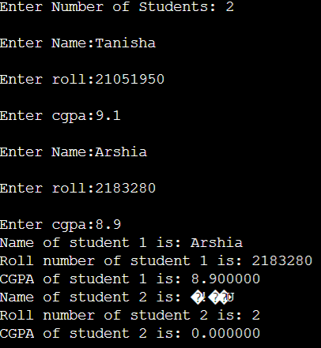

**Q4. WAP to store n employee’s data such as employee name, gender, designation, department, basic pay. Calculate the gross pay of each employees as follows:**

**Gross pay = basic pay + HR + DA**

**HR=25% of basic and DA=75% of basic.**

#include<stdio.h>

#include <string.h>

struct employee{

char name[50];

char gen[10];

char dg[50];

char dpt[50];

float pay;

};

int main(){

int i;

int x=0;

printf("Enter Number of Employee: ");

scanf("%d",&x);

struct employee e[x];

for(i=0;i<x;i++){

printf("\nEnter Name:");

scanf("%s",&e[i].name);

printf("\nEnter Gender(F/M/Not Say):");

scanf("%s",&e[i].gen);

printf("\nEnter Designation:");

scanf("%s",&e[i].dg);

printf("\nEnter Department:");

scanf("%s",&e[i].dpt);

printf("\nEnter Basic Pay:");

scanf("%f",&e[i].pay);

}

printf("\nGross pay:");

for(i=0;i<x;i++){

int hr,da;

int p= e[i].pay;

hr = (25/100)*p;

da = (75/100)*p;

e[i].pay = hr+da+p;

printf("\nName:%s, Gross Pay: %f ",e[i].name,e[i].pay);

}

return 0;

}

**Output:**

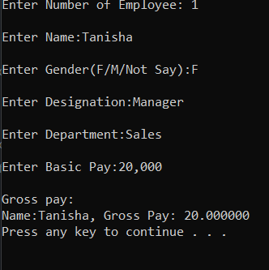

**Q5. WAP to declare one distance structure (with members kilometer and meter) and create the variables for addition of two distances using Pointers to structure.**

**10km500m--D1**

**21km600m--D2**

**D3.meter=D1.meter+D2.meter (100)**

**D3.KM=D1.KM+D2.KM (32)**

**If(D3.meter>=1000)**

**D3.KM++;**

**D3.meter=D3.meter-1000;**

#include<stdio.h>

#include<stdlib.h>

struct Distance{

int km;

int m;

};

int main(){

struct Distance *d1 = NULL;

struct Distance *d2 = NULL;

struct Distance *d3 = NULL;

d1 = (struct Distance*)malloc(sizeof(struct Distance));

d2 = (struct Distance*)malloc(sizeof(struct Distance));

d3 = (struct Distance*)malloc(sizeof(struct Distance));

printf("Enter metres for first distance: ");

scanf("%d", &d1->m);

printf("Enter kilometres for first distance: ");

scanf("%d", &d1->km);

printf("Enter metres for second distance: ");

scanf("%d", &d2->m);

printf("Enter kilometres for second distance: ");

scanf("%d", &d2->km);

printf("Total metres: %d \n", d1->m);

printf("Total kilo metres: %d \n", d1->km);

while(d3->m >= 1000){

d3->km = d3->km + 1000;

d3->m = d3->m = 1000;

}

printf("Total metres: %d \n", d3->m);

printf("Total kilo metres: %d \n", d3->km);

}

**Output:**

